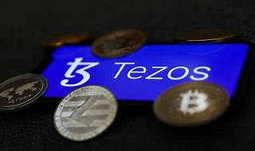

Explore

**Tezos** is an **open-source platform** for assets and applications that can evolve by upgrading itself. [It addresses key barriers facing blockchain adoption and is backed by a global community of validators, researchers, and builders1](https://tezos.com/learn/what-is-tezos).

Here are **five free reference links** where you can learn more about Tezos:

1. [**Tezos Official Website**](https://tezos.com/learn/what-is-tezos): This is the official Tezos website, providing comprehensive information about the platform, its features, and use cases[1](https://tezos.com/learn/what-is-tezos).
2. [**Ledger Academy**](https://www.ledger.com/academy/topics/blockchain/what-is-tezos): Ledger Academy offers an introduction to Tezos, covering topics such as self-amendment, DeFi, blockchain games, and NFTs[2](https://www.ledger.com/academy/topics/blockchain/what-is-tezos).
3. [**Investopedia**](https://www.investopedia.com/terms/t/tezos.asp): Learn about Tezos as a blockchain network hosting the associated digital token Tez (XTZ), which is used in DeFi, decentralized applications, and NFT projects[3](https://www.investopedia.com/terms/t/tezos.asp).
4. [**Blockchain Council**](https://www.blockchain-council.org/blockchain/what-is-tezos-pros-and-cons/): Explore the pros and cons of Tezos, along with its open-source blockchain protocol and global community[4](https://www.blockchain-council.org/blockchain/what-is-tezos-pros-and-cons/).
5. [**CoinGecko Learn and Earn**](https://landing.coingecko.com/earn/what-is-tezos/): CoinGecko provides lessons on Tezos, including creating a wallet, understanding NFTs, and minting NFTs on the Tezos blockchain[5](https://landing.coingecko.com/earn/what-is-tezos/).

Feel free to explore these resources to deepen your understanding of Tezos! 🌟